How to Use OpenAI API Key

1. Create a key

Login on <https://platform.openai.com/account/api-keys>

1. 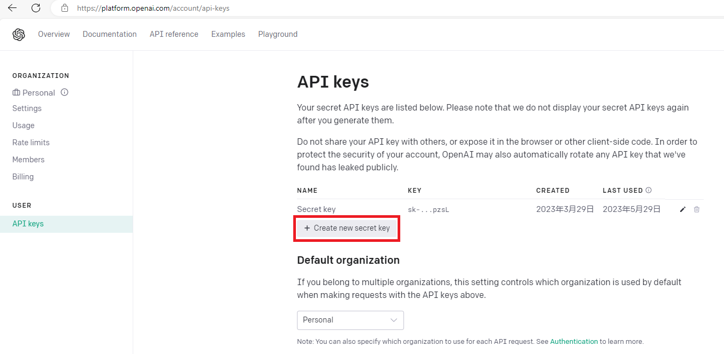View API keys and Create a new secret key

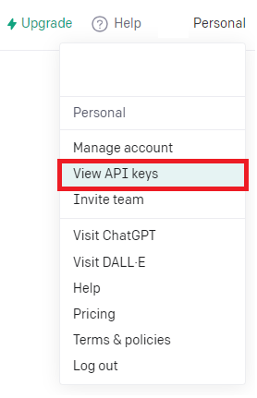

1. 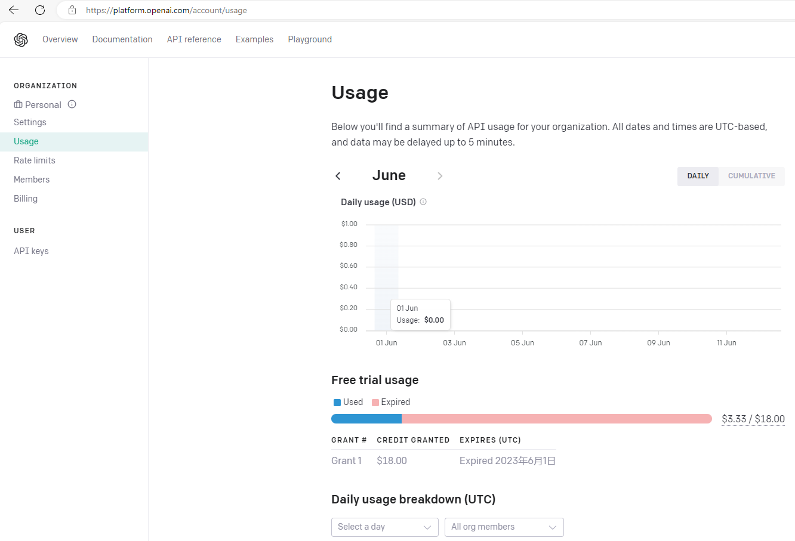You get some free trial money in your account and check the usage
2. Put it into your system environment variable

Console Plane -> System Setting -> Environment Variables -> System Variables

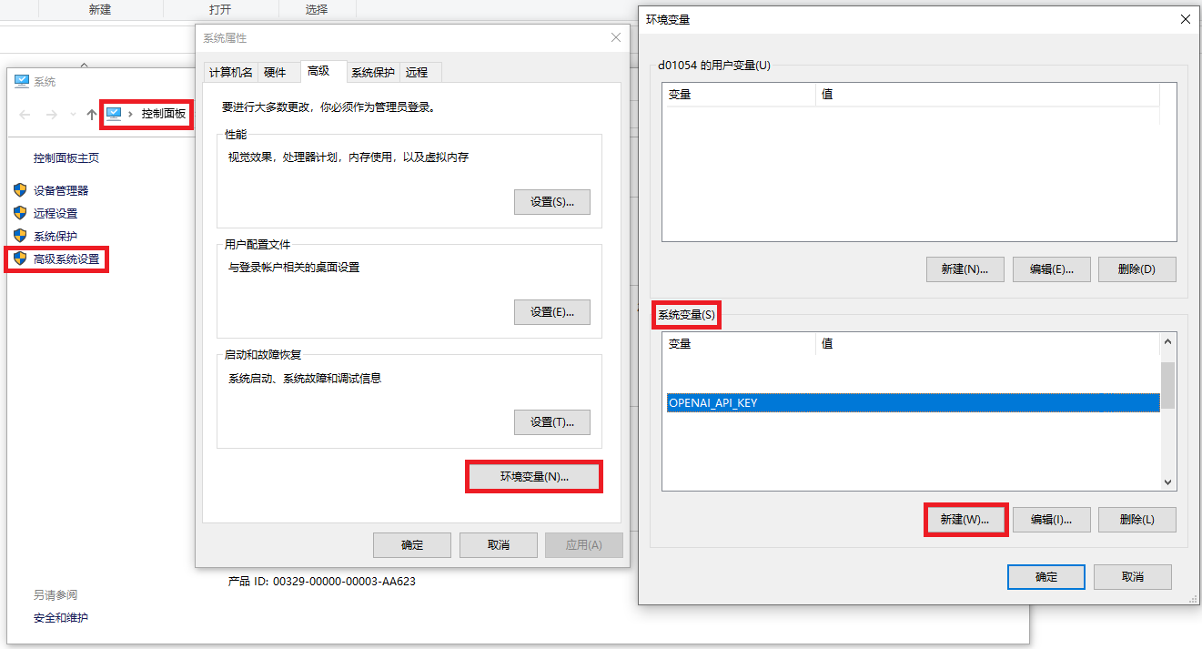Add ‘OPENAI_API_KEY’ here

1. Import OS and call os.environ.get('OPENAI_API_KEY') and Call Image.create

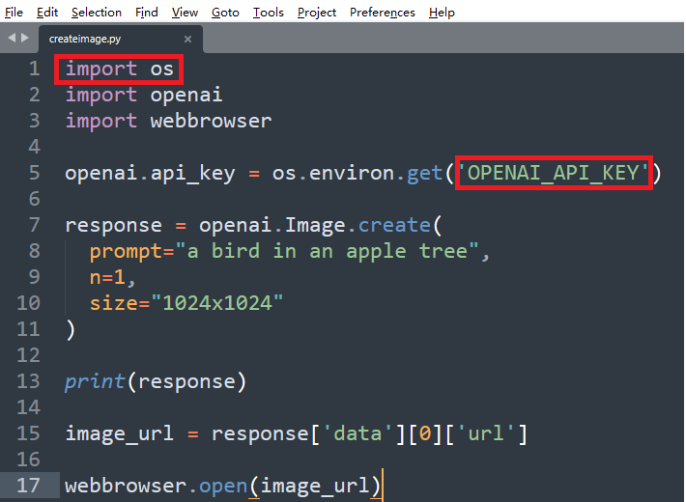

1. Other Documentation and API reference

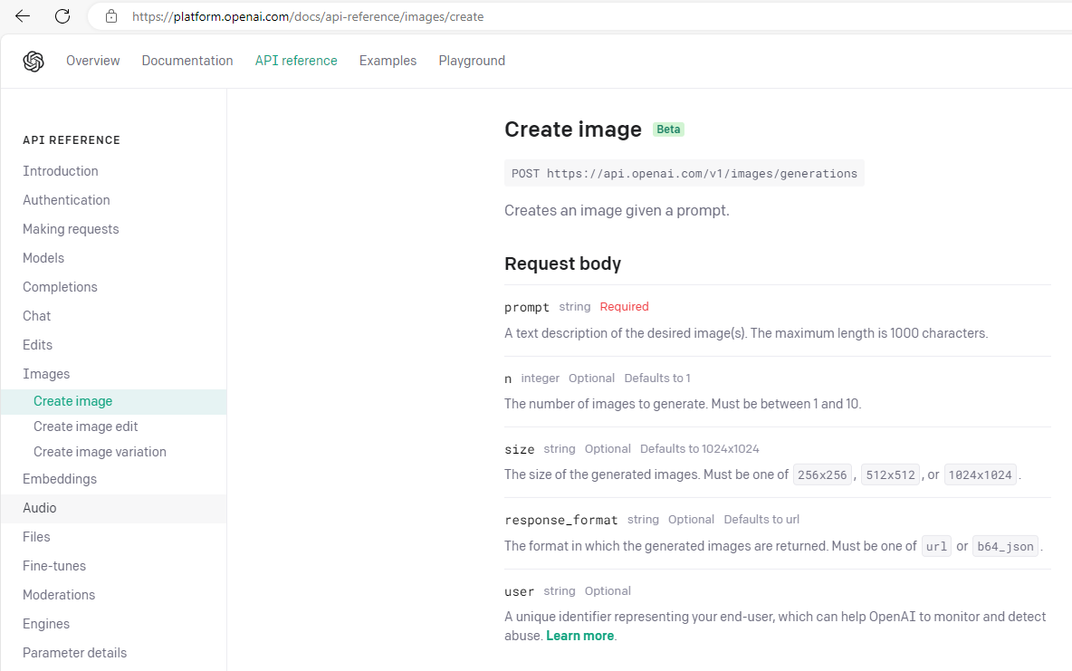

1. Use chatGPT to generate the code:

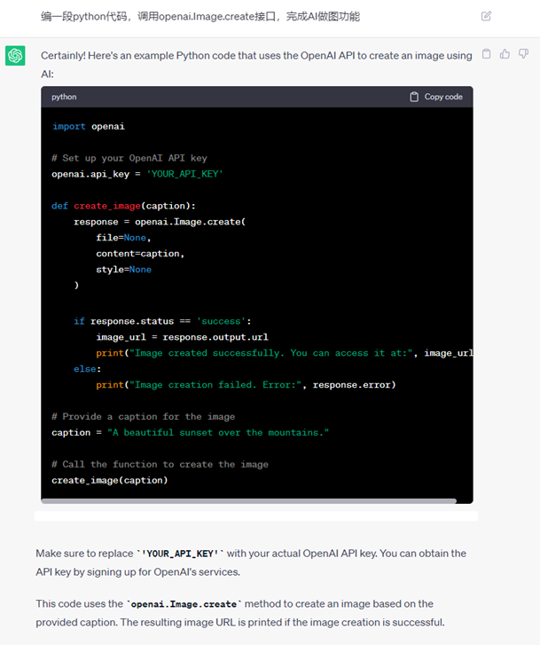

Note:

It is not a good practice to directly copy the API key into the code as it can easily lead to key exposure. It is better to use the method mentioned above with environment variables.